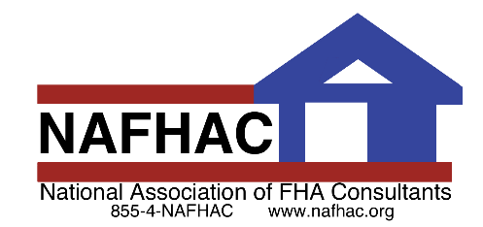

Break

'N'

203k

**Are you a first-time homebuyer eager to get into the market? Here are steps to take to help you decide whether you’re ready to take the plunge…**

**Do’s & Don’ts for**

**First-Time Home Buyers:**

DO a quick search of actual multiple listing service, or MLS, listings in your area on a number of websites, including the National Association of Realtors, to check the selling prices of comparable homes in your area.

DO use a mortgage calculator online to get an idea of what your monthly mortgage payments would be if you purchased a home today.

DO calculate what your total monthly housing cost would be, including taxes and homeowners’ insurance. In some areas, what you pay for taxes and insurance escrow can almost double your mortgage payment!

DO invest in a professional inspection. Sellers don’t always disclose the whole truth to potential buyers. Home inspectors can look beyond the fresh coat of paint to find costly underlying problems. Splurge on the experienced professional—it will save you time, money and house-induced heartache later on.

DON’T buy a house for its décor. Look past a home’s décor and make sure the space will accommodate your lifestyle and furnishings.

DON’T trust everything you read in a real estate ad. Like any ad, real estate classifieds are meant to pique your interest enough to make you want a closer look. Be a savvy buyer and decode the clever phrases sellers use to draw you in. For example: “cozy” may be a code word for “small”.

DON’T buy the most expensive house on the block. You won’t get the same return on investment with the biggest house and you may have trouble selling later on.

“Home is the nicest word there is.”

~Laura Ingalls Wilder

Call Today!

xxx-xxx-xxxx



**www.YOURCOMPANY.com**

Mention THIS FLYER or code word: HOME4JUNE to receive

$50 off your June 2020 Home Inspection Fee of $350 or more.

Mention code when scheduling to receive discount. Promotion ends 6/30/2020.

**Rebuilding Neighborhoods, One Home at a Time**

(See other side for some of the things that make us different)

**Why Use** YOUR COMPANY?

(enter your USPs below-see examples from Catherine’s former company)

* **20+ Years of Inspection & Building Consultation Experience**
* **200% No Risk Guarantee!** (call for details)
* **Free 30-Day Inspection!** (If for any reason the house we inspected falls through, Value Home Inspections, Inc. will inspect your next house for ***FREE*** if scheduled and performed within 30 days!)
* **Certified FHA 203(k) Consultant**
* **Certified Member of ASHI & InterNACHI**



***Your company name*** *for all your inspection needs!*

***Call Now! (xxx) xxx-xxxx***

***Add another USP and state why it benefits the agent and the buyer.***

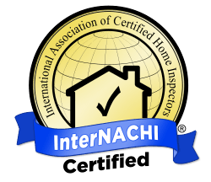

**What are the advantages to using an FHA 203(k) Rehabilitation loan?**

1. There is a larger pool of properties available to show.
2. There is no need to negotiate for the seller to do repairs.
3. Many homes can be turned into the client’s dream home.
4. You have less liability to a client who wants to buy a “unique fixer-upper”
5. Consultants are professionally trained to ensure smooth projects from initial consultation to final draw.
6. Client can take advantage of energy efficiency improvements that reduce operating costs with 203k and/or EEM loans.
7. Client can get money/cash rebates and tax incentives for the upgrades that are done.
8. Client gets instant equity once renovation is completed due to increased home value and can refinance after six months.

