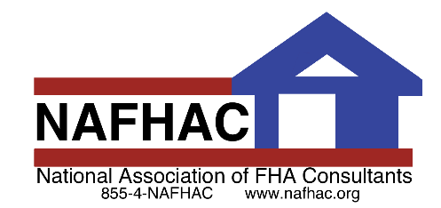

Break N' 203k

Call Today!

xxx-xxx-xxxx

January 2021

**Your Phone Number**

**Your LOGO**

**WOW! The Power of a 203k.**

**(place your own rehab pics or remove this line)**

### **What Kind of Properties Quality for a 203k?**

Qualifying homes for an FHA 203k loan include*:*

* *A one- to four-family home that has been completed for a least a year*
* *A home that has been torn down, if some of the existing foundation is still in place*
* *A home that you want to move to a new location*
* *The home cannot be a co-op, but some condos are eligible*

The property will also have to qualify under the usual [FHA requirements](http://www.zillow.com/mortgage-learning/fha-loan/#requirements). For example, its value cannot exceed a certain maximum amount, which depends on where the property is located.

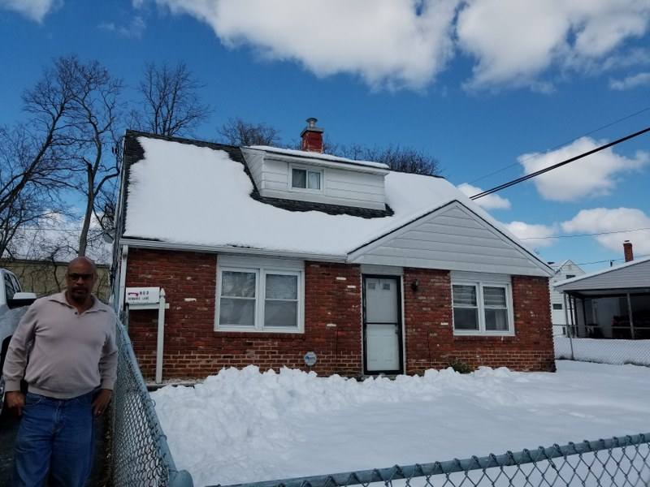

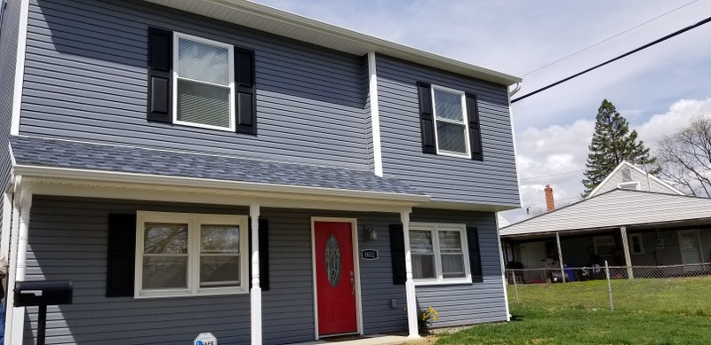

**BEFORE**

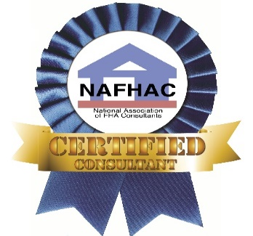

**AFTER**

**Want to learn more about FHA 203k Loans and how it can help you close more deals?**

As a certified consultant with the National Association of FHA Consultants “NAFHAC” I am qualified and equipped to provide an educational presentation on 203k’s.

Give me a call at {Phone number}. Together we can…

**Rebuilding Neighborhoods, One Home at a Time**

(See other side for some of the things that make us different)



Your LOGO

**Why Use Your Business Name Here?**Put in a series of reasons why agents should hand out your brochure;

(**for example:)**

* Senior Home Inspector & Certified 203(k) Consultant
* 20+ Years’ Experience in Building Inspections
* Experienced Customer Service Agents
* Full Color Photo Report Available Next Day!
* Call 800-XXX-XXXX or email info@yourbusinessname.com

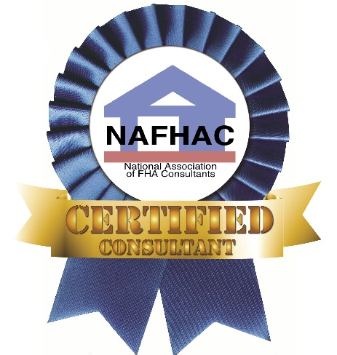

***YOUR COMPANY for all your residential consulting needs.***

***Call Now! (xxx) xxx-xxxx***



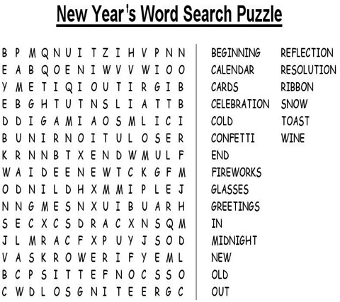

If you can’t fly, then run,

if you can’t run, then walk,

if you can’t walk, then crawl,

but whatever you do,

you have to keep moving forward.”

~Martin Luther King, Jr.

1929-1968

