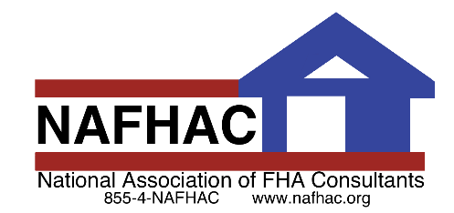

Break N’ 203K

Call Today!
xxx-xxx-xxxx

December 2020
Your Phone Number
Your LOGO
Have you seen the POWER of an FHA 203k?
If you want to learn more about how together we can save and make more deals call me today.
(place your own rehab pics or remove this line)

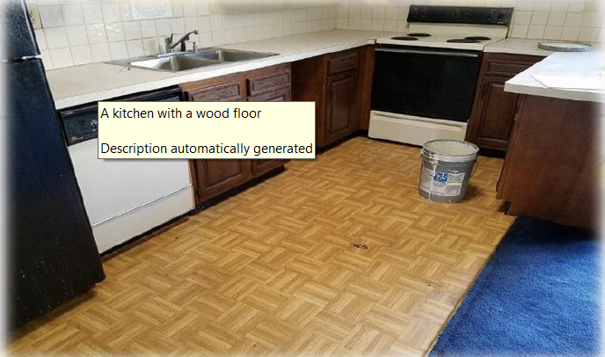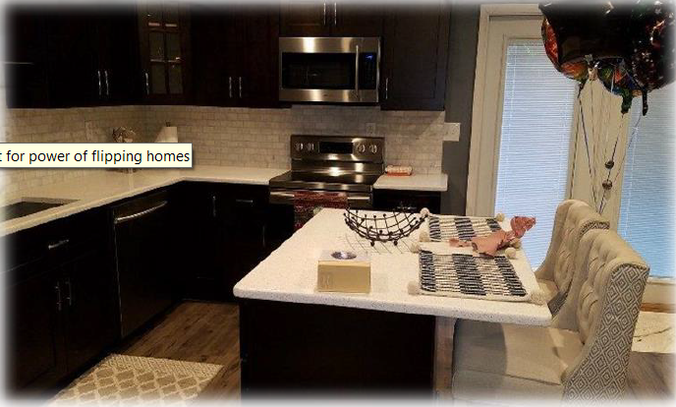
AFTER
BEFORE
Place your Business Contact Info Here

Add Another UniqueSellingPoint
(for example: Appointments available Afternoons & Saturdays!)

State why this USP benefits the agent and the buyer!

CALL TODAY!
1-800-XXX-XXXX
(Change to your #)

Visit our Website:

www.CompanyWebsite.com

(Advertise your own
coupon for any of your services!)

Rebuilding Neighborhoods, One Home at a Time
(See other side for some of the things that make us different)

Why Use Your Business Name Here?
Put in a series of reasons why agents should hand out your brochure;
(for example:)
- Senior Home Inspector & Certified 203(k) Consultant
- 20+ Years’ Experience in Building Inspections
- Experienced Customer Service Agents
- Full Color Photo Report Available Next Day!
- Call 800-XXX-XXXX or email info@yourbusinessname.com

Your LOGO

YOUR COMPANY for all your residential consulting needs.
Call Now! (xxx) xxx-xxxx

Wine Glass Snow Globe Candle Holder
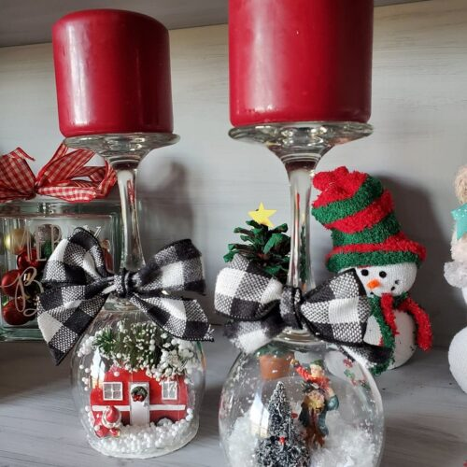
Materials:

- Wine Glass
- Hot Glue Gun
- Figurines/Ornaments
- White Paint
- Sturdy Cardboard
- Ribbon
- Pillar Candle

Instructions:

- Trace the bottom of a wine glass on a piece of thin cardboard. Cut it out. Paint it white and let dry.
- Pour some fake snow or balls in the wine glass. Glue on your figurines to the cardboard circle.
- Put hot glue around the rim of the wine glass then tip the figurines upside-down and press around the edges. If any snow falls out add extra hot glue.
- (Optional) Paint the outside bottom rim with white paint and sprinkle with glitter or snow! If there's excess cardboard just cut it off.
- Tie a bow with ribbon and hot glue it on.
- Top with a pretty pillar candle!

