Place Your Company Logo Here
Change header to your phone #
May 2020

Place your Business Contact Info Here

Add Another UniqueSellingPoint
(for example: Appointments available Afternoons & Saturdays!)

State why this USP benefits the agent and the buyer!

CALL TODAY!
1-800-XXX-XXXX
(Change to your #)

Visit our Website:

www.CompanyWebsite.com

FHA 203k Loan: Getting to the table
203k Loan Process
THREE Phases = ONE Happy Borrower

- Before Borrower Signs Agreement
After they have chosen their new home

- Before Ordering the Appraisal
The consulting process will determine what the appraiser will use to determine value

- Before the Borrower/Contractor’s First Draw
A properly executed first draw sets the tone of the entire process –last impressions are lasting impressions

Your borrower needs a 203k loan…
What comes first?
- Clearly establish borrower’s goals/needs?
- Connect the borrower with the FHA Consultant BEFORE they order ANY inspections.
- Get a clear understanding of the condition of the home.
- Determine the borrower’s margin for extra costs and repairs?

Would you like to learn more about FHA 203k Loans and how it can help you close more deals?
As a certified consultant with the National Association of FHA Consultants “NAFHAC” I am qualified and equipped to provide an educational presentation on 203k’s. Give me a call at {Phone number}.
Together we can…
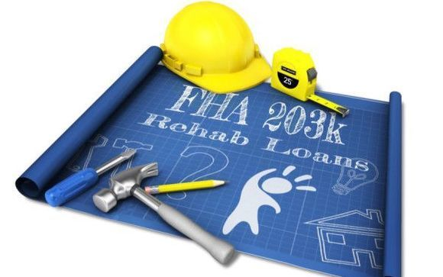
Why Use (Your Business Name Here)?
(Put in a series of reasons why agents should hand out your brochure) for example:

- 203k Helps Save The Deal
- Certified 203k NAFHAC Rehab Consultant
- Senior Home Inspector
- 20+ Years’ Experience in Building Inspections
- Experienced Customer Service Agents

CALL 1-800-XXX-XXXX
or
EMAIL info@yourbusinessname.com

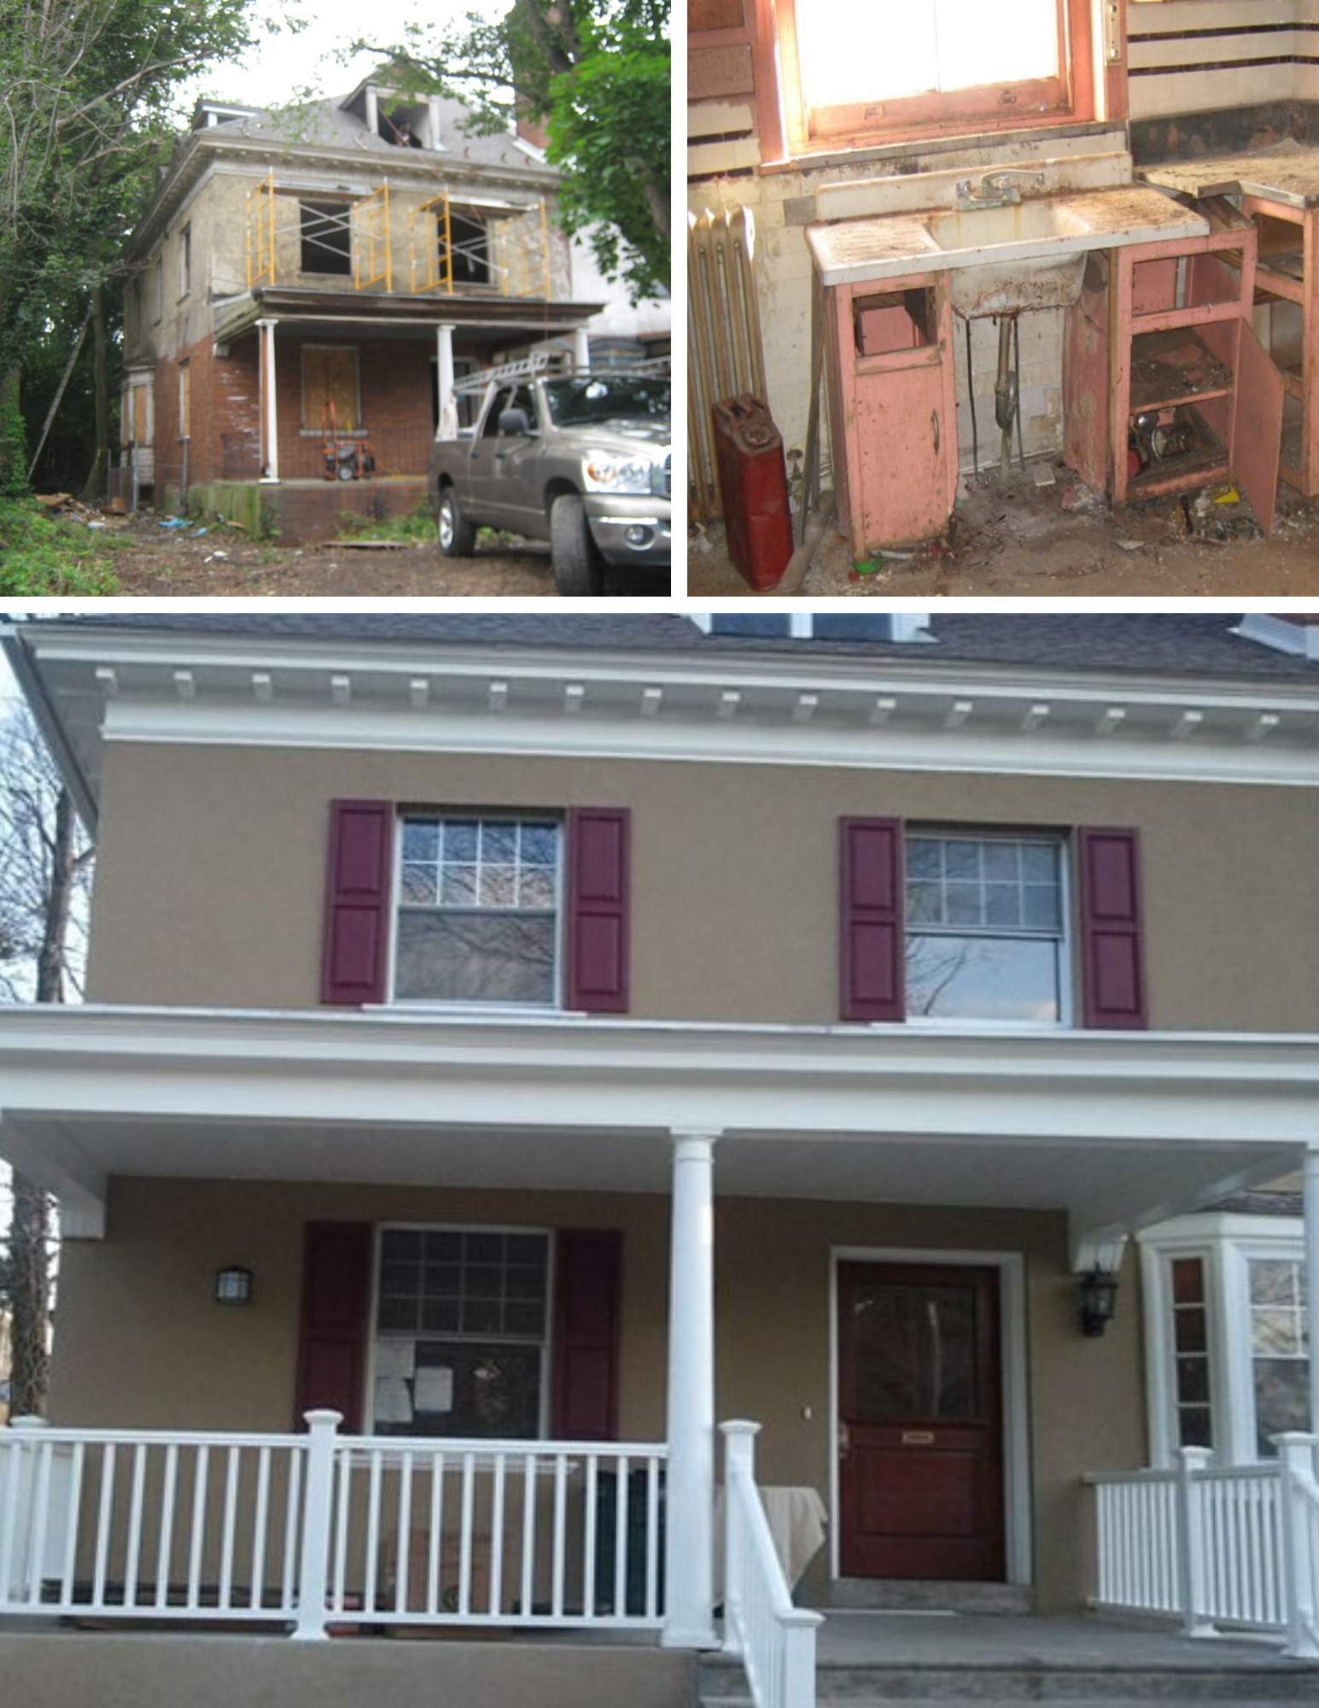

BEFORE…
&
AFTER!

B
AFTER

