**JULY 2020**

**Change header to your phone #**

**Place Your Company Logo Here**

Place your **Business Contact Info Here**

Add Another **UniqueSellingPoint**

(for example: Appointments available Afternoons & Saturdays!)

State why this USP benefits the agent and the buyer!

CALL TODAY!

1-800-XXX-XXXX

(Change to your #)

Visit our Website:

www.CompanyWebsite.com

**Have you told your buyer, that an FHA 203k loan covers both repairs and purchase?**

**NO, what are you waiting for?**

**Providing your clients with this tip is your Christmas gift to them in July!**

Are you tired of showing your clients newly renovated expensive homes and your clients aren’t happy with the kitchen because it didn’t have an island?

What they might be looking for is a 203k loan, now you can show them older homes that can sometimes be found at a great bargain and all the need is some TLC.

A 203k rehab loan - enables home buyers to have the purchase price and estimated cost of repairs into a single mortgage right up front.

The FHA 203k loan can cover repairs, improvements or both on a residential property. Unlike traditional financing, which typically requires separate loans to purchase the property, pay for repairs and then [refinance](https://www.mortgageloan.com/refinance-mortgage) everything into a long-term mortgage when the work is done, a 203k mortgage allows everything to be financed through a single transaction.

Does this sound like something that you would be beneficial to you and your clients?

**Christmas Puzzle**

**Give me a call at {Phone number}.**

**As a certified consultant with the National Association of FHA Consultants “NAFHAC” I am qualified and equipped to provide to provide you with more information on 203k loans and the roll of a FHA consultant.**

Together we can..

**Rebuild Neighborhoods… ONE home at a time!**



**(Erase**

**before printing)**



**Why Use (Your Business Name Here)?**(Put in a series of reasons why agents should hand out your brochure)

(for example:)

* 203k Helps Save The Deal
* Certified 203k NAFHAC Rehab Consultant
* Senior Home Inspector
* 20+ Years’ Experience in Building Inspections
* Experienced Customer Service Agents

CALL 1-800-XXX-XXXX or EMAIL *info@yourbusinessname.com*

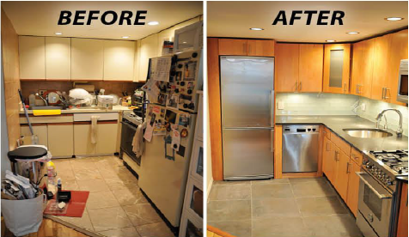

**Change to your email**

