Call Toll Free
800-xxx-xxxx
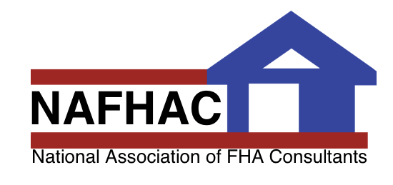
Ask the
REHAB CONSULTANT…

Question:

Hi there! With Memorial Day right around the corner, a lot of my clients are looking for houses with pool decks and patios. Is there anything in the 203k loan that allows for pool or deck repair? Thanks for your help!

~Robert Tollman in Bartlett, IL

Dear Robert,

Thanks for your question!
This is one we hear a lot! Home buyers want to know if the FHA 203k loan will cover exterior improvements. The Section 203(k) loan covers a wide range of home improvements. These include, but are not limited to, the following:

- Replacing a roof, gutters, and downspouts
- Adding a porch, deck, or patio
- Major landscape work and site improvement, patios and terraces that improve the value of the property equal to the dollar amount spent on the improvements or required to preserve the property from erosion
- Completing a basement or attic conversion or adding a second story
- Expanding or building a garage or carport
- Renovating a deteriorating property, such as repairing a chimney, termite damage, or structural problem
- Adding or repairing siding or repainting
- Installing energy efficient windows or doors
- Repairing an existing swimming pool

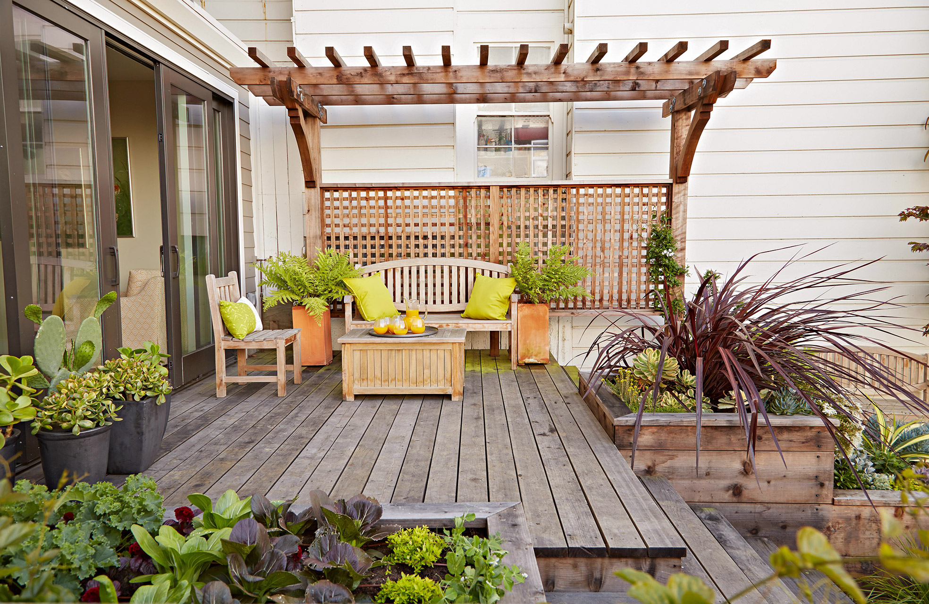

The FHA 203k loan can NOT add a swimming pool to a home, only repair an existing structure. This should help give your clients a better idea of what an FHA 203k loan will and will not cover. Good luck!

Happy Memorial Day!

Put a USP or Testimonial Here


 If you have questions about FHA 203k, home inspection or home maintenance, Ask the Consultant! E-mail your questions to memberservices@nafhac.org

Rebuilding Neighborhoods, One Home at a Time
(See other side for some of the things that make us different)

Why Use NAFHAC FHA Building Consultants?

- Put in a series of reasons in here for why agents should hand out your name.
- There should be an odd number of bullet points.
- Don’t be afraid to bullet point a USP you used elsewhere in the flyer.

- Make sure these are reasons an agent would be better off by using you
- A great one is "All inspections performed by FHA 203k Consultants" (if applicable).
- Reason A
- Reason B

My Pledge to You
I dedicate 100% of my time and energy delivering First-Class service to YOU, my customer.
My philosophy about real estate is simple. I put myself in your shoes, treat you like family and treat your money like it was my money.
The greatest compliment I can receive is a referral from you to a friend or family member.
My goal…is to become Your personal building consultant for life!



What are the advantages to using an FHA 203k Rehabilitation loan?

- There is a larger pool of properties available to show.
- Many homes can be turned into the client’s dream home.
- You have less liability to a client who wants to buy a “unique fixer upper”
- Consultants are professionally trained to ensure smooth projects from initial consultation to final draw.
- Client can take advantage of energy efficiency improvements that reduce operating costs with 203k and/or EEM loans.
- Client can get money/cash rebates and tax incentives for the upgrades that are done.
- Client gets instant equity once renovation is completed due to increased home value and can refinance after six months.

NAFHAC FHA Building Consultant for all your inspection needs.

Add Another USP or Testimonial.

Remember a picture will make your testimonial twice as effective!

Call Toll-Free

1-800-xxx-xxxx

Add a caption for your picture – or a USP telling an agent how you can help her.

